**How to run architecture tool**

**Run configuration:-**

**Step 1:**  open run configuration

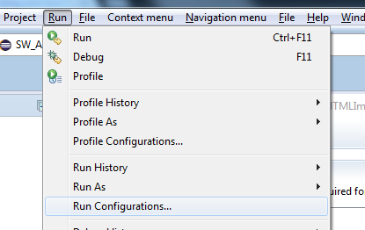

**Step 2:**  double click on eclipse application

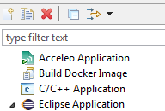

**Step 3:** give a configuration name in location field and select “eclipse.org.emf.ecp.application.e3.product” in run a product field.

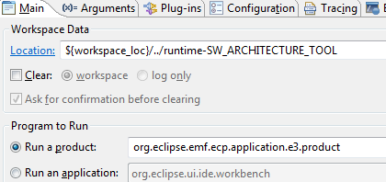

**Step 3:** go plug-in tab select “features selected below” in lunch with field then click on “deselect all” button then select“org.eclipse.emf.ecp.demo.e3.feature” plug-in then click on “required plug-in” then click on “add plug-in” button select your own plug-in and click on run.

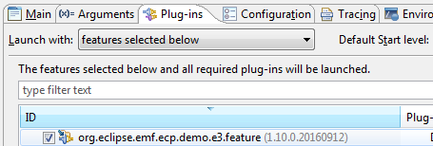

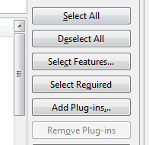

**Note:** Install ECP,Xtext,Xpand from eclipse install new software menu.

2.) Install Rhapsody plugins in eclipse.

In VM Arguments:

-Dosgi.requiredJavaVersion=1.7 –Xms256m –Xmx1024m

Djava.library.path=”\your path till dll \”